Standard operating practices for Ricebean germplasm characterization

Dr. Gayacharan

Scientist, ICAR-NBPGR, New Delhi

Email: [gayacharan@icar.gov.in](mailto:gayacharan@icar.gov.in); Mob: 09868667395

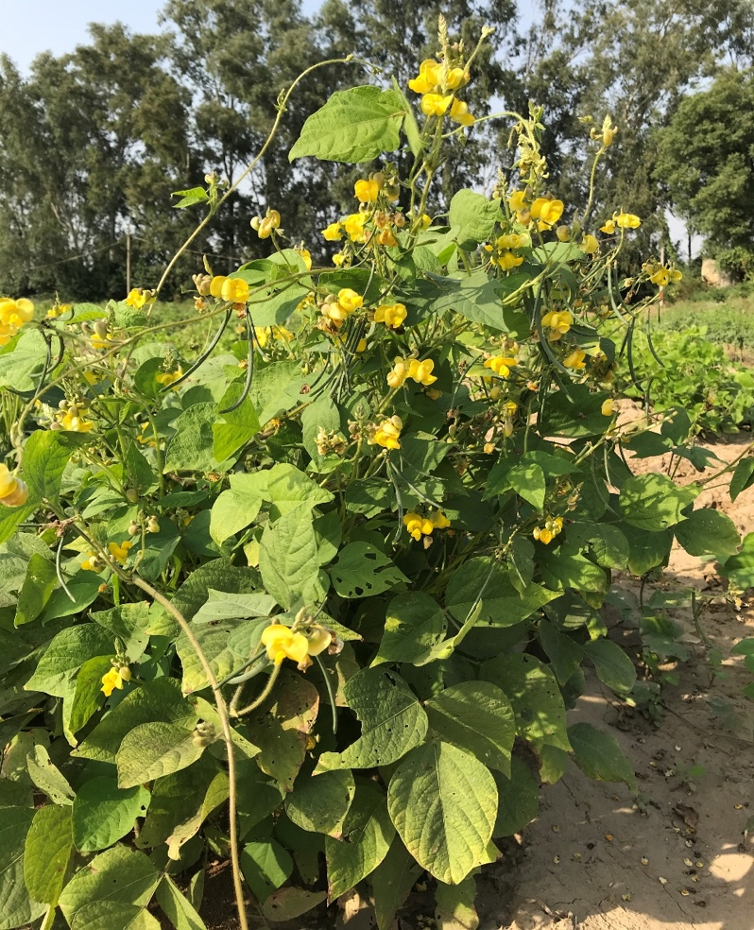

Following practices will be followed in conducting the ricebean characterization experiment.

1. **Climatic and soil requirement:** The crop Ricebean is known for its diverse distribution and range of adaptation from humid subtropical to warm and cool temperate climate. The crop requires average temperature of 18-30° C temperature for better growth. During its sowing time it needs around 30-35° C. And well distributed rainfall of 80-150 cm during the growing period is enough. Well drained loamy to sandy loam soils with moderate fertility are the best. Ricebean is highly sensitive to salinity and water logging.
2. **Seed treatment:** Treat the seeds with Thiamethoxam 75 WS (Cruiser) @ 4g/kg + Carbendazim @ 1g/kg + Thiram @ 1 g/kg of seed 1 to 10 days before sowing. The required seed quantity (200-300 seeds/acc.) may be put in Petri dish and estimated quantity of chemicals along with adhesive compound may be mixed together. After overnight drying seed should be transferred to the respective envelop.
3. **Field preparation:**

Field should have very good drainage to avoid flooding during heavy monsoon rains.

FYM and or compost (@5-8 tonns/ha) should be applied in the field as per the requirement of the field just before the ploughing of the field.

Apply fertilizers as basal @ 25 kg N + 50 kg P2O5 + 25 kg K2O + 20 kg Sulphur/ha.

Field should be given termite treatment (Chlorpyrifos 20 EC @ 1.25 kg ai/ha).

Pre-emergence herbicide should be applied to control weeds in the field within 24 hrs of sowing. A dilution of Pendimethalin 30% EC @ 3.0-4.0 ltr in 500-700 ltr water will be enough for one hectare land.

1. **Sowing:** In North Indian climatic conditions rice bean germplasm must be sown within 1st to 2nd week of July to get proper expression of germplasm. Row to row spacing should be kept 45 cm and plant to plant spacing should be kept 10 cm. each accession should be sown in paired row. A gap of a row (45cm) should be given between two accessions to avoid mechanical contamination.
2. **Irrigation:** The crop is drought tolerant, so monsoon rains are enough. In case of long gap of monsoon rains, one or two irrigations may be required in Delhi conditions.
3. **Insect/disease control:** During flowering stage, if blister beetle (*Mylabris pustulata*) appears in the field, application of Decis (Deltamethrin 2.8 EC (2.8% w/w) is very effective. If any sign of spotted pod borer (*Maruca testulalis*) is seen in the field, immediate spray of Indoxacarb (Avant) or Spinosad (Tracer®) or Dicholorovas or Ekalux 25 EC@2ml/ ltr water or Nuvan 100 @2ml/ l water should be done.
4. **Weeding and thinning:** Regular weeding should be done. Thinning should be done within 10-15 days of sowing during first weeding. Hoeing should be done after each rain/irrigation till the pod formation stage from the first flower flush is over in majority of the accessions.
5. **Trailing of accessions:** This activity has to be done after 30 days of crop growth after thinning and weeding is done.
6. **Field lay out and Experimental Design:** Augmented Block Design (ABD) will be followed in which representative mungbean checks will be repeated in each block. Entire field should be divided in to homogenous blocks of equal size. No checks should be on border. Block size will be decided based on the dimension of the field. Sowing should be as below:

|  |  |  |  |  |  |  |  |
| --- | --- | --- | --- | --- | --- | --- | --- |
| Bed No. | 1 | 2 | 3 | 4 | 5 | 6 | 7 |
| Sr. No. | 1 | 100 | 101 | 200 | 201 | 300 | 301 |
|  |  |  |  |  |  |  |  |
|  |  |  |  |  |  |  |
|  |  |  |  |  |  |  |
|  |  |  |  |  |  |  |  |
| Sr. No. | 50 | 51 | 150 | 151 | 250 | 251 | 350 |

**Checks:** VRB-3, BRS-2, PRR-1, PRR-2 and RBL-6

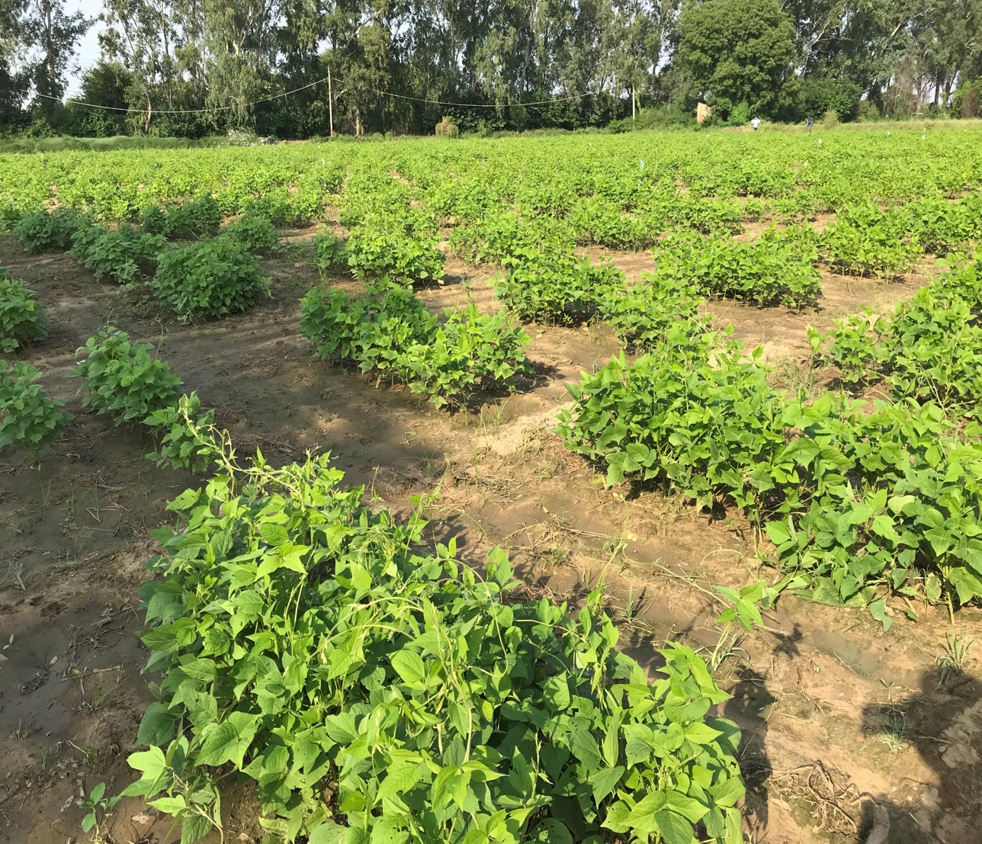

1. **Accessions labeling:** Each accession including checks must be labeled just after sowing. At least checks should be labeled while sowing itself. Serial number of germplasm should remain as given by the ICAR-NBPGR to avoid mislabeling and for ease of data and seed handling at Genebank, ICAR-NBPGR. Each label will have serial number, accession ID, Season, year, location (e.g. 125, IC23567, K-2019, Badnapur). Preferably checks should have different label colour. Each check will be given serial number of its previous accession along with word check (e.g. 300Check, IPM 2-3, K-2019, Badnapur).
2. **Data recording:** Each descriptor (which is given to you) should be recorded on right stage of the plant (which is mentioned in the descriptors list).
3. **Harvesting:** Multiplepod plucking has to be done in muslin clothe bags in accessions having asynchronous type of flowering period. For synchronous type accessions single harvesting is enough. Before harvesting all the field data should be completed. For taking ‘yield/plant’ total plant in an accession will be count and average yield will be taken (as separating individual plant becomes difficult task in rice bean).
4. **Postharvest data recording:** seed from a single pant representing major phenotype of the accession should be harvested separately in envelops and postharvest data like 100 seed weight, seed luster, seed shape and other seed morphometric data will be done from the same seed.
5. **Bulk harvesting:** rest of the plant (five + one) will be harvested as bulk. Each muslin clothe bag containing seed will have half part of the label inside it and rest half will be outside it.
6. **Photographs:** Quality photographs will be taken and labelled. Field photographs and comparative photographs of germplasm diversity will be taken (e.g. pod length, seed size, seed color, leaf size, raceme position, plant height, etc.). Wherever comparative length is measured, like pod length, scale will be used for comparison. For documenting colour variation, RHS colour chart will be used along with the specimen while taking photo.

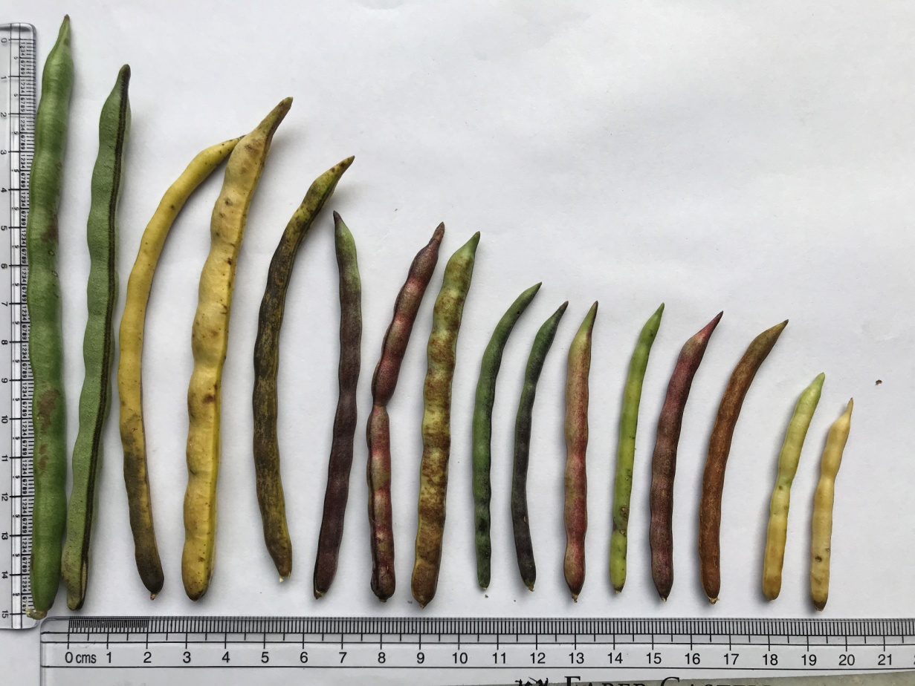

Tentative timelines for ricebean characterization Kharif, 2019 and kharif 2020

|  |  |  |  |  |  |  |  |  |  |  |  |  |  |  |  |  |  |  |  |  |  |  |  |  |
| --- | --- | --- | --- | --- | --- | --- | --- | --- | --- | --- | --- | --- | --- | --- | --- | --- | --- | --- | --- | --- | --- | --- | --- | --- |
| **Month** | **June** | **July** | | | | **August** | | | | **September** | | | | **October** | | | | **November** | | | | **December** | | |
| **Week** | 4 | 1 | 2 | 3 | 4 | 1 | 2 | 3 | 4 | 1 | 2 | 3 | 4 | 1 | 2 | 3 | 4 | 1 | 2 | 3 | 4 | 1 | 2 | 3 |
| **Field preparation** |  |  |  |  |  |  |  |  |  |  |  |  |  |  |  |  |  |  |  |  |  |  |  |  |
| **Seed treatment** |  |  |  |  |  |  |  |  |  |  |  |  |  |  |  |  |  |  |  |  |  |  |  |  |
| **Sowing** |  |  |  |  |  |  |  |  |  |  |  |  |  |  |  |  |  |  |  |  |  |  |  |  |
| **Insecticide spray** |  |  |  |  |  |  |  |  |  |  |  |  |  |  |  |  |  |  |  |  |  |  |  |  |
| **Thinning & weeding** |  |  |  |  |  |  |  |  |  |  |  |  |  |  |  |  |  |  |  |  |  |  |  |  |
| **Accessions Labelling** |  |  |  |  |  |  |  |  |  |  |  |  |  |  |  |  |  |  |  |  |  |  |  |  |
| **Trailing of accessions** |  |  |  |  |  |  |  |  |  |  |  |  |  |  |  |  |  |  |  |  |  |  |  |  |
| Seedling Vigour |  |  |  |  |  |  |  |  |  |  |  |  |  |  |  |  |  |  |  |  |  |  |  |  |
| Terminal leaflet type |  |  |  |  |  |  |  |  |  |  |  |  |  |  |  |  |  |  |  |  |  |  |  |  |
| Terminal leaf length |  |  |  |  |  |  |  |  |  |  |  |  |  |  |  |  |  |  |  |  |  |  |  |  |
| Terminal leaf Width |  |  |  |  |  |  |  |  |  |  |  |  |  |  |  |  |  |  |  |  |  |  |  |  |
| Flower ground colour (outer surface of banner) |  |  |  |  |  |  |  |  |  |  |  |  |  |  |  |  |  |  |  |  |  |  |  |  |
| Growth habit |  |  |  |  |  |  |  |  |  |  |  |  |  |  |  |  |  |  |  |  |  |  |  |  |
| Leafiness |  |  |  |  |  |  |  |  |  |  |  |  |  |  |  |  |  |  |  |  |  |  |  |  |
| Leaf colour |  |  |  |  |  |  |  |  |  |  |  |  |  |  |  |  |  |  |  |  |  |  |  |  |
| Branching pattern |  |  |  |  |  |  |  |  |  |  |  |  |  |  |  |  |  |  |  |  |  |  |  |  |
| Plant height |  |  |  |  |  |  |  |  |  |  |  |  |  |  |  |  |  |  |  |  |  |  |  |  |
| Plant stem diameter |  |  |  |  |  |  |  |  |  |  |  |  |  |  |  |  |  |  |  |  |  |  |  |  |
| Pod pubescence |  |  |  |  |  |  |  |  |  |  |  |  |  |  |  |  |  |  |  |  |  |  |  |  |
| Pod Colour |  |  |  |  |  |  |  |  |  |  |  |  |  |  |  |  |  |  |  |  |  |  |  |  |
| No. of branches/plant |  |  |  |  |  |  |  |  |  |  |  |  |  |  |  |  |  |  |  |  |  |  |  |  |

|  |  |  |  |  |  |  |  |  |  |  |  |  |  |  |  |  |  |  |  |  |  |  |  |  |
| --- | --- | --- | --- | --- | --- | --- | --- | --- | --- | --- | --- | --- | --- | --- | --- | --- | --- | --- | --- | --- | --- | --- | --- | --- |
| **Month** | **June** | **July** | | | | **August** | | | | **September** | | | | **October** | | | | **November** | | | | **December** | | |
| **Week** | 4 | 1 | 2 | 3 | 4 | 1 | 2 | 3 | 4 | 1 | 2 | 3 | 4 | 1 | 2 | 3 | 4 | 1 | 2 | 3 | 4 | 1 | 2 | 3 |
| No. of pods/plant |  |  |  |  |  |  |  |  |  |  |  |  |  |  |  |  |  |  |  |  |  |  |  |  |
| No. of peduncles/plant |  |  |  |  |  |  |  |  |  |  |  |  |  |  |  |  |  |  |  |  |  |  |  |  |
| No. of pods/cluster |  |  |  |  |  |  |  |  |  |  |  |  |  |  |  |  |  |  |  |  |  |  |  |  |
| Days to 80% maturity |  |  |  |  |  |  |  |  |  |  |  |  |  |  |  |  |  |  |  |  |  |  |  |  |
| Pod length |  |  |  |  |  |  |  |  |  |  |  |  |  |  |  |  |  |  |  |  |  |  |  |  |
| No. of seeds/pod |  |  |  |  |  |  |  |  |  |  |  |  |  |  |  |  |  |  |  |  |  |  |  |  |
| Leaf senescence |  |  |  |  |  |  |  |  |  |  |  |  |  |  |  |  |  |  |  |  |  |  |  |  |
| Pod colour (mature) |  |  |  |  |  |  |  |  |  |  |  |  |  |  |  |  |  |  |  |  |  |  |  |  |
| **Harvesting** |  |  |  |  |  |  |  |  |  |  |  |  |  |  |  |  |  |  |  |  |  |  |  |  |
| Grain yield/plant |  |  |  |  |  |  |  |  |  |  |  |  |  |  |  |  |  |  |  |  |  |  |  |  |
| **Post harvest data** |  |  |  |  |  |  |  |  |  |  |  |  |  |  |  |  |  |  |  |  |  |  |  |  |
| 100 seed weight |  |  |  |  |  |  |  |  |  |  |  |  |  |  |  |  |  |  |  |  |  |  |  |  |
| Seed colour |  |  |  |  |  |  |  |  |  |  |  |  |  |  |  |  |  |  |  |  |  |  |  |  |
| Seed shape |  |  |  |  |  |  |  |  |  |  |  |  |  |  |  |  |  |  |  |  |  |  |  |  |
| **Data typing** |  |  |  |  |  |  |  |  |  |  |  |  |  |  |  |  |  |  |  |  |  |  |  |  |

**List of descriptors for Ricebean characterization and preliminary evaluation**

|  |  |  |  |  |
| --- | --- | --- | --- | --- |
| **Sr. No.** | **Character** | **Stage** | **Descriptor State** | **Description** |
|  | Seedling Vigour | At 15 days after emergence | 3 Poor  5 Intermediate  7 Vigorous |  |
|  | Terminal leaflet type | After 30 days of plant growth | 1 Narrow (elongate)  2 Intermediate (sub-elliptic)  3 Rounded (sub-orbicular)  4 Others (specify) |  |
|  | Terminal leaf length (cm) | After 30 days of plant growth |  | Five randomly selected plants (Recorded for the leaf at the fourth node) |
|  | Terminal leaf Width (cm) | After 30 days of plant growth |  | Five randomly selected plants (Recorded for the leaf at the fourth node) |
|  | Flower ground colour (outer surface of banner) | During full flowering | 1 Yellow  2 Purple-yellow  3 Blackish yellow  4 other (specify) |  |
|  | Growth habit | During 50% flowering | 1 Erect  2 Semi-erect  3 Spreading | Straight and prominent main stem with few branches ascend  Main stem less prominent; branches do not touch ground  Branches touch ground |
|  | Leafiness | At 50% flowering | 3 Sparse  5 Intermediate  7 Abundant |  |
|  | Leaf Colour | During 50% flowering | 3 Light green  5 Intermediate green  7 Dark Green |  |
|  | Branching pattern | During 50% flowering | 1 Basal  2 Central  3 Top  4 All over |  |
|  | Plant height (cm) | After 50% flowering to grain filling stage |  | Five randomly selected plants |
|  | Plant stem diameter (cm) | Flowering to maturity stage |  | Five randomly selected plants (just below the first node of the plant) |
|  | No. of branches/plant | When first pod changes colour |  | Five randomly selected plants (Count only pod bearing branches whose origin is in the leaf axils on the main stem) |
|  | Pod colour (near mature pod) | When pods start maturing | 1 Light yellow  2 Brown  3 Blackish brown  4 Green-purple  5 Light purple  6 Purple  7 Other |  |
|  | No. of pods/plant | When 80% of plants have mature pods |  | Five randomly selected plants (Pods from first flowering flush only counted) |
|  | No. of peduncles/plant | When 80% of plants have mature pods |  | Count of five randomly selected individual plants |
|  | No. of pods/cluster | When 80% of plants have mature pods |  | Count cluster in central branch of five randomly selected individual plants |
|  | Days to 80% maturity | When 80% of plants have mature pods |  |  |
|  | Pod length (cm) | When pods are mature |  | Five randomly selected plants (Longest pods from each selected plant) |
|  | No. of seeds/pod | When 80% of plants have mature pods |  | Five randomly selected plants (The length of the longest pods) |
|  | Leaf senescence | When 50 % pods dried | 0 No  3 Slight  5 Moderate  7 Concurrent |  |
|  | Pod colour (mature) | When 80% of plants have mature pods | 1 Straw  2 Tan  3 Brown  4 Brown-Black  5 Black |  |
|  | Grain yield/plant (g) | After harvest |  | Five randomly selected plants |
|  | 100 seed weight (g) | After harvest |  | Take randomly 100 seeds |
|  | Seed colour | After harvest | 1 Light green  2 Dark green  3 Green-yellow  4 Yellow  5 Brown  6 Mottled green  7 Mottled brown  8 Mottled grey  9 Others (specify) |  |
|  | Seed shape | After harvest | 1 Cylindrical  2 Round  3 Flattend  4 Other (specify) |  |